**Table 1. Baseline patient and tumour characteristics by centre.**

|  |  |  |  |  |  |
| --- | --- | --- | --- | --- | --- |
|  | **Total (N=4071)** | **Center A (N=983)** | **Center B (N=1343)** | **Center C (N=566)** | **Center D (N=1179)** |
| **Positive SN status** | 889 (21.8%) | 236 (24.0%) | 259 (19.3%) | 170 (30.0%) | 224 (19.0%) |
| **Males** | 1996 (49.0%) | 497 (50.6%) | 753 (56.1%) | 273 (48.2%) | 473 (40.1%) |
| **Age** |  |  |  |  |  |
| Median (Q1, Q3) | 55.0 (43.0, 66.0) | 55.0 (43.0, 65.0) | 62.0 (48.0, 71.0) | 52.0 (40.0, 62.0) | 51.0 (42.0, 62.0) |
| Min - Max | 13.0 - 94.0 | 15.0 - 89.0 | 13.0 - 94.0 | 13.0 - 88.0 | 15.0 - 83.0 |
| **Ulceration** | 1171 (28.8%) | 265 (27.0%) | 263 (19.6%) | 166 (29.3%) | 477 (40.5%) |
| Missing | 141 (3.5%) | 30 (3.1%) | 31 (2.3%) | 68 (12.0%) | 12 (1.0%) |
| **Location** |  |  |  |  |  |
| Arm | 615 (15.1%) | 128 (13.0%) | 217 (16.2%) | 86 (15.2%) | 184 (15.6%) |
| Leg | 1189 (29.2%) | 277 (28.2%) | 324 (24.1%) | 218 (38.5%) | 370 (31.4%) |
| Trunk | 1815 (44.6%) | 407 (41.4%) | 654 (48.7%) | 242 (42.8%) | 512 (43.4%) |
| Head/neck | 314 (7.7%) | 138 (14.0%) | 142 (10.6%) | 20 (3.5%) | 14 (1.2%) |
| Missing | 138 (3.4%) | 33 (3.4%) | 6 (0.4%) | 0 (0.0%) | 99 (8.4%) |
| **Histology** |  |  |  |  |  |
| SSM | 2164 (53.2%) | 598 (60.8%) | 910 (67.8%) | 285 (50.4%) | 371 (31.5%) |
| NM | 1226 (30.1%) | 276 (28.1%) | 290 (21.6%) | 195 (34.5%) | 465 (39.4%) |
| ALM | 126 (3.1%) | 29 (3.0%) | 54 (4.0%) | 16 (2.8%) | 27 (2.3%) |
| Other | 202 (5.0%) | 53 (5.4%) | 46 (3.4%) | 14 (2.5%) | 89 (7.5%) |
| Missing | 353 (8.7%) | 27 (2.7%) | 43 (3.2%) | 56 (9.9%) | 227 (19.3%) |
| **Breslow** |  |  |  |  |  |
| Mean (SD) | 2.8 (3.3) | 2.6 (2.0) | 2.3 (2.5) | 2.8 (2.3) | 3.6 (4.9) |
| Min - Max | 0.1 - 90.0 | 0.5 - 22.0 | 0.1 - 30.0 | 0.3 - 20.0 | 0.1 - 90.0 |
| Missing | 59 (1.4%) | 9 (0.9%) | 16 (1.2%) | 6 (1.1%) | 28 (2.4%) |
| **Multiple fields** | 374 (9.2%) | 223 (22.7%) | 41 (3.1%) | 87 (15.4%) | 23 (2.0%) |
| **Total number of negative SN** |  |  |  |  |  |
| Mean (SD) | 1.7 (1.4) | 2.2 (1.6) | 1.6 (1.3) | 1.6 (1.4) | 1.2 (1.0) |
| Min - Max | 0.0 - 15.0 | 0.0 - 15.0 | 0.0 - 13.0 | 0.0 - 10.0 | 0.0 - 9.0 |
| Missing | 162 (4.0%) | 0 (0.0%) | 27 (2.0%) | 1 (0.2%) | 134 (11.4%) |
| **Total number of positive SN** |  |  |  |  |  |
| Mean (SD) | 0.3 (0.6) | 0.3 (0.6) | 0.2 (0.4) | 0.4 (0.7) | 0.3 (0.6) |
| Min - Max | 0.0 - 5.0 | 0.0 - 4.0 | 0.0 - 2.0 | 0.0 - 4.0 | 0.0 - 5.0 |
| Missing | 1 (0.0%) | 0 (0.0%) | 1 (0.1%) | 0 (0.0%) | 0 (0.0%) |
| **SN tumour burden** |  |  |  |  |  |
| Mean (SD) | 1.2 (1.3) | 1.1 (0.8) | 1.0 (0.5) | 1.1 (1.3) | 1.4 (2.0) |
| Min - Max | 0.0 - 38.0 | 0.0 - 8.0 | 0.0 - 8.0 | 0.0 - 15.0 | 0.0 - 38.0 |
| Missing | 301 (7.4%) | 120 (12.2%) | 163 (12.1%) | 18 (3.2%) | 0 (0.0%) |
| **Location metastasis lymph** |  |  |  |  |  |
| Subcap | 3319 (81.5%) | 793 (80.7%) | 1123 (83.6%) | 440 (77.7%) | 963 (81.7%) |
| Combined | 213 (5.2%) | 39 (4.0%) | 27 (2.0%) | 43 (7.6%) | 104 (8.8%) |
| Parenchymal | 86 (2.1%) | 5 (0.5%) | 11 (0.8%) | 19 (3.4%) | 51 (4.3%) |
| Multifocal | 45 (1.1%) | 6 (0.6%) | 9 (0.7%) | 21 (3.7%) | 9 (0.8%) |
| Extensive | 105 (2.6%) | 18 (1.8%) | 10 (0.7%) | 25 (4.4%) | 52 (4.4%) |
| Missing | 303 (7.4%) | 122 (12.4%) | 163 (12.1%) | 18 (3.2%) | 0 (0.0%) |
| **Mitosis > 1 mm2** | 135 (3.3%) | 50 (5.1%) | 0 (0.0%) | 85 (15.0%) | 0 (0.0%) |
| Missing | 3895 (95.7%) | 906 (92.2%) | 1343 (100.0%) | 467 (82.5%) | 1179 (100.0%) |
| **Recurrence** | 862 (21.2%) | 208 (21.2%) | 175 (13.0%) | 160 (28.3%) | 319 (27.1%) |
| **Deaths** | 606 (14.9%) | 127 (12.9%) | 148 (11.0%) | 115 (20.3%) | 216 (18.3%) |
| **Melanoma specific mortality** | 504 (12.4%) | 98 (10.0%) | 101 (7.5%) | 102 (18.0%) | 203 (17.2%) |
| **Follow-up time in years** | 4.79 [4.60; 4.94] | 4.75 [4.48; 4.98] | 2.73 [2.46; 3.03] | 6.33 [6.06; 7.07] | 6.19 [5.91; 6.73] |

Abbreviations: Q1, first quantile (Q1); Q3, third quantile; SD, standard deviation; SN, sentinel node, SSM, superficial spreading melanoma; NM, nodular melanoma; ALM, acral lentiginous melanoma.

**Table 2. Full model predicting 5-year recurrence**. This Table displays the hazard ratios together with the 95 percent confidence intervals of the full Cox proportional hazards model predicting 5-year recurrence.

|  |  |  |  |  |  |  |
| --- | --- | --- | --- | --- | --- | --- |
|  | **Negative SN** | | **Positive SN** | | **Importance** | |
|  | **HR** | **CI** | **HR** | **CI** | **Main** | **Int.** |
| **Positive SN status** |  |  | 1.211 | [0.17; 8.55] | 38.6 | 22.1 |
| **Male** | 1.24 | [1.03; 1.50] | 0.98 | [0.61; 1.59] | 5.1 | 2.5 |
| **Age** | 1.17 | [0.87; 1.59] | 1.63 | [0.76; 3.52] | 8.4 | 2.0 |
| **Ulceration** | 1.75 | [1.43; 2.14] | 1.38 | [0.83; 2.29] | 35.5 | 2.3 |
| **Location** |  |  |  |  |  |  |
| Arm | (ref) |  | (ref) |  |  |  |
| Leg | 1.37 | [1.02; 1.85] | 1.17 | [0.46; 2.97] | 22.4 | 1.0 |
| Trunk | 1.49 | [1.12; 2.00] | 1.20 | [0.49; 2.93] |  |  |
| Head and neck | 2.31 | [1.59; 3.36] | 1.62 | [0.53; 4.95] |  |  |
| **Histology** |  |  |  |  |  |  |
| SSM | (ref) |  | (ref) |  |  |  |
| NM | 1.20 | [0.96; 1.50] | 1.30 | [0.75; 2.26] | 9.9 | 0.4 |
| ALM | 1.56 | [0.94; 2.60] | 1.42 | [0.41; 4.87] |  |  |
| Other | 1.01 | [0.67; 1.55] | 1.13 | [0.29; 4.41] |  |  |
| **Breslow** | 2.15 | [1.87; 2.47] | 1.54 | [1.08; 2.20] | 144.6 | 9.0 |
| **Multiple fields** | 1.32 | [0.97; 1.81] | 1.37 | [0.65; 2.92] | 6.3 | 0.0 |
| **Total number of nodes** | 0.97 | [0.92; 1.03] | 0.99 | [0.83; 1.16] | 1.0 | 0.0 |
| **SN tumour burden** |  |  | 1.17 | [1.04; 1.31] | 6.6 |  |
| **Location metastasis in lymph node** |  |  |  |  |  |  |
| Subcap |  |  | (ref) |  |  |  |
| Combined |  |  | 1.38 | [0.94; 2.02] | 6.2 |  |
| Parenchymal |  |  | 0.95 | [0.58; 1.55] |  |  |
| Multifocal |  |  | 0.92 | [0.55; 1.55] |  |  |
| Extensive |  |  | 1.15 | [0.70; 1.89] |  |  |
| *C-index2* | 0.77 | [0.75; 0.78] |  |  |  |  |
| *C-index recalibrated MSM2* | 0.78 | [0.76; 0.80] |  |  |  |  |

1The hazard ratio of positive sentinel node patients includes the effects from the interaction terms. 2The C-index is corrected for optimism. Abbreviations: SN, sentinel node; HR, hazard ratio; CI, 95 percent confidence interval; Importance defined by the chi-square Wald-statistic; Main the Wald-statistic for the main effect of the coefficient; Int., the Wald-statistic for the interaction term with positive SN status; SSM, superficial spreading melanoma; NM, nodular melanoma; ALM, acral lentiginous melanoma; MSM, melanoma specific mortality.

**Table 3. Final model predicting 5-year recurrence**. This Table displays the hazard ratios together with the 95 percent confidence intervals of the full Cox proportional hazards model predicting 5-year recurrence selected by backward selection with p-values maximum of 0.01.

|  |  |  |  |  |  |  |
| --- | --- | --- | --- | --- | --- | --- |
|  | **Negative SN** | | **Positive SN** | | **Importance** | |
|  | **HR** | **CI** | **HR** | **CI** | **Main** | **Int.** |
| **Positive SN status** |  |  | 2.79 | [2.34; 3.33] | 140.5 |  |
| **Age** | 1.42 | [1.13; 1.78] | 1.42 | [1.13; 1.78] | 9.2 |  |
| **Ulceration** | 1.63 | [1.40; 1.91] | 1.63 | [1.40; 1.91] | 39.5 |  |
| **Location** |  |  |  |  |  |  |
| Arm | (ref) |  | (ref) |  |  |  |
| Leg | 1.30 | [1.01; 1.68] | 1.30 | [1.01; 1.68] | 22.1 |  |
| Trunk | 1.46 | [1.15; 1.86] | 1.46 | [1.15; 1.86] |  |  |
| Head and neck | 2.03 | [1.49; 2.75] | 2.03 | [1.49; 2.75] |  |  |
| **Breslow** | 2.27 | [2.02; 2.56] | 1.55 | [1.14; 2.10] | 207.7 | 16.1 |
| **SN tumour burden** |  |  | 1.21 | [1.11; 1.31] | 19.2 |  |
| *C-index1* | 0.76 | [0.75; 0.78] |  |  |  |  |
| *C-index recalibrated MSM1* | 0.78 | [0.76; 0.80] |  |  |  |  |

1The C-index is corrected for optimism. Abbreviations: SN, sentinel node; HR, hazard ratio; CI, 95 percent confidence interval; Importance defined by the chi-square Wald-statistic; Main the Wald-statistic for the main effect of the coefficient; Int., the Wald-statistic for the interaction term with positive SN status.

**Figure 1. Risk distribution and nomogram**.

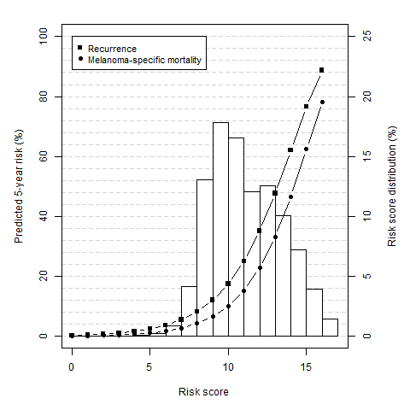

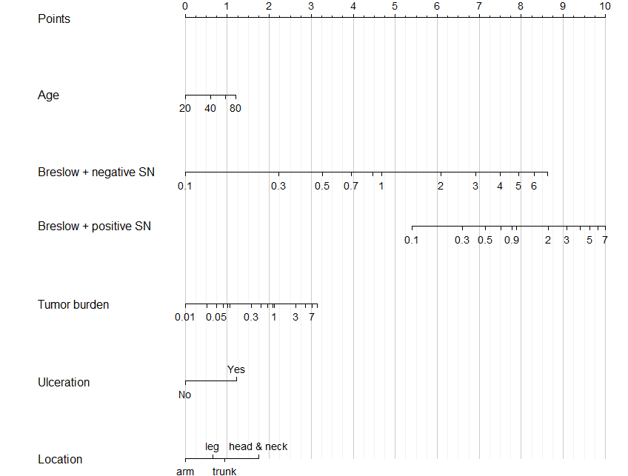

**Figure 1. Calibration curves of the final model predicting recurrence for each centre for all patients obtained using leave-one-out internal-external validation.**

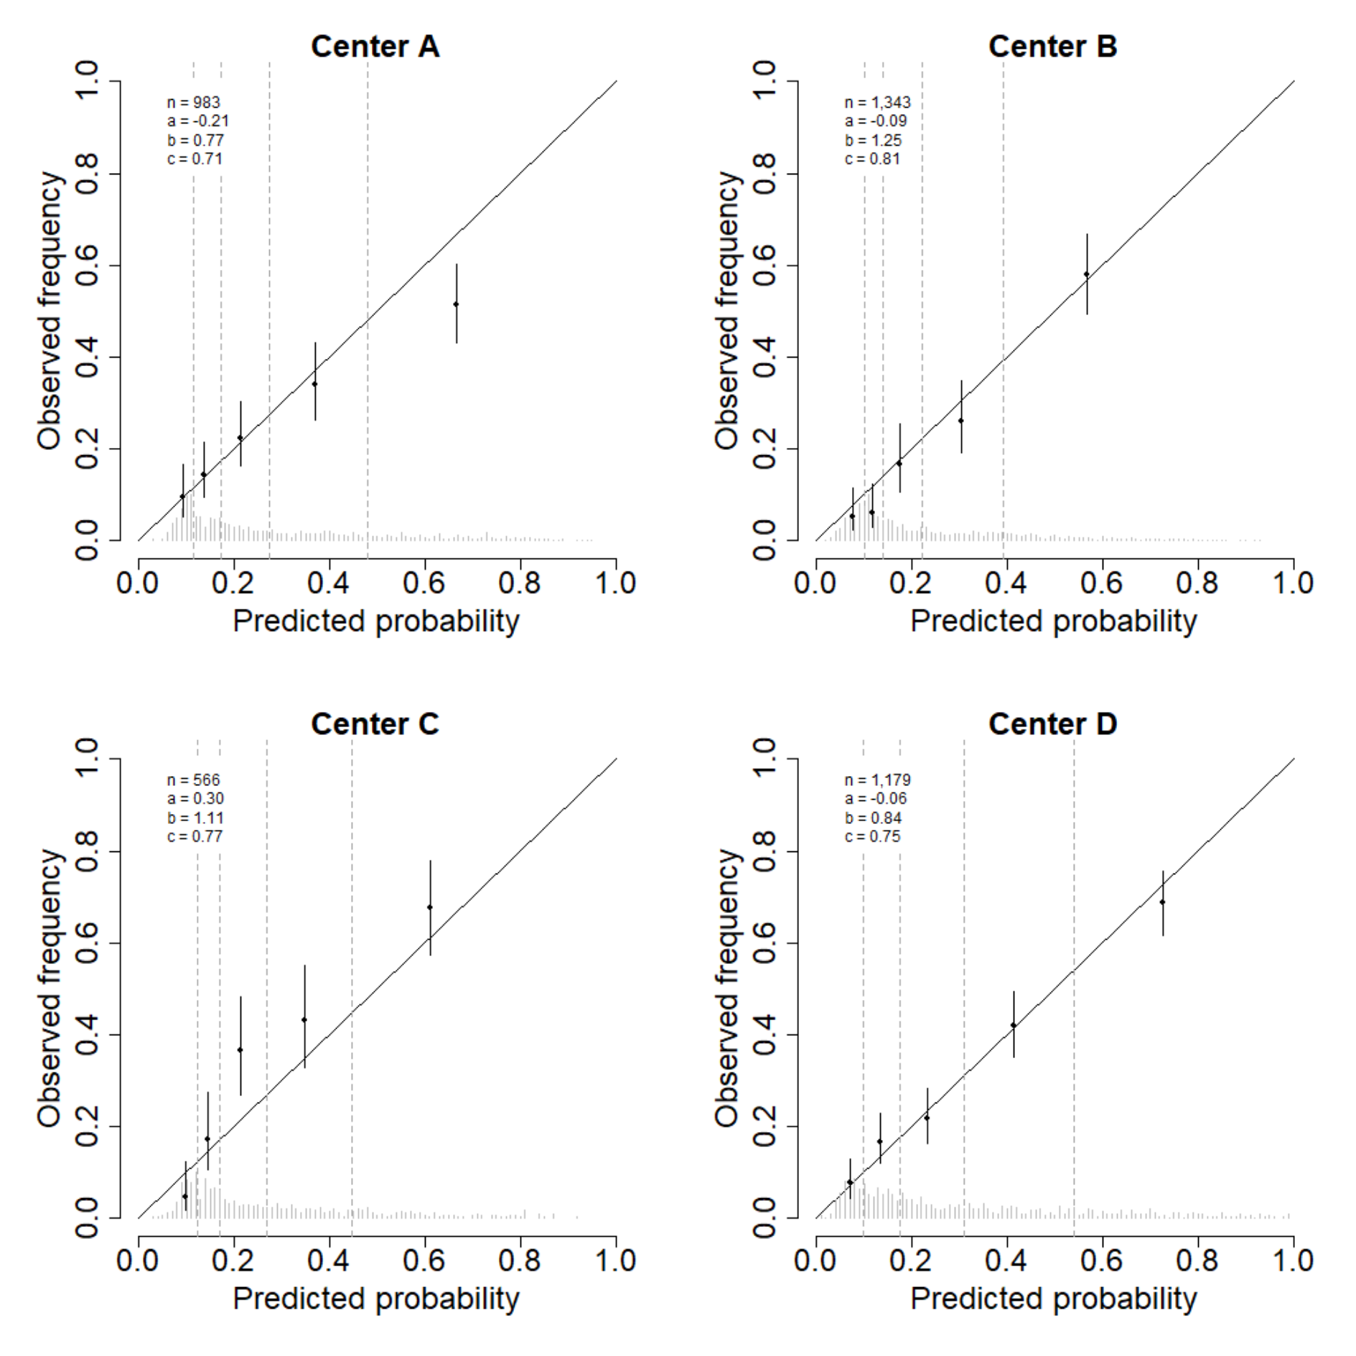

**Figure 2. Calibration curves of the final calibrated model predicting melanoma specific mortality for each centre for all patients obtained using leave-one-out internal-external validation.**

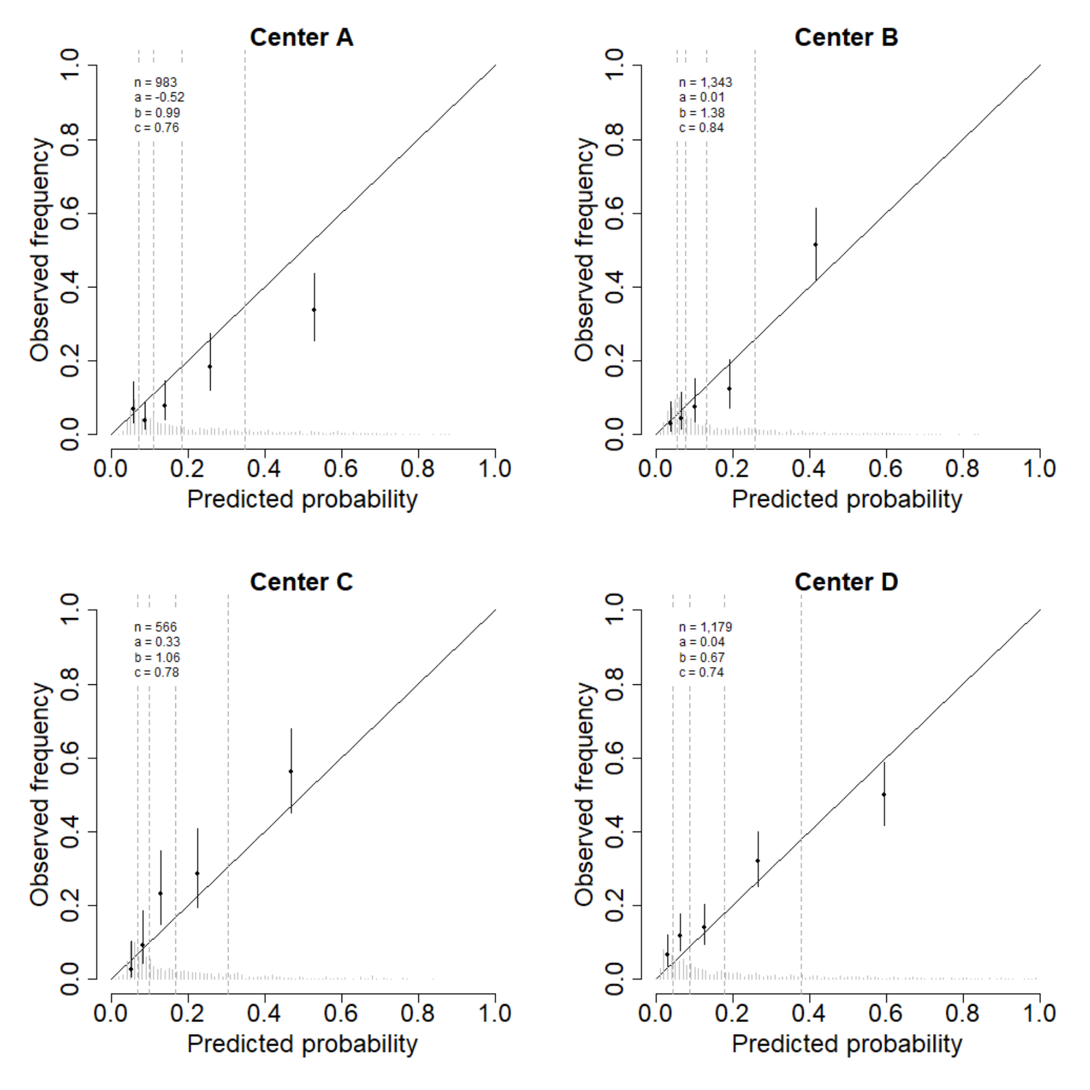

**SUPPLEMENT**

**Figure S1. Calibration curve of the final model predicting recurrence for patients from all centres with positive and negative sentinel nodes obtained using leave-one-out internal-external validation.**

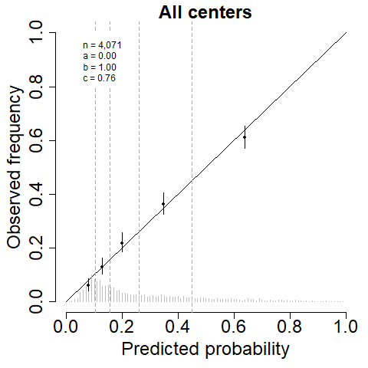

**Figure S2. Calibration curve of the final refitted model predicting melanoma-specific mortality for patients from all centres with positive and negative sentinel nodes obtained using leave-one-out internal-external validation.**

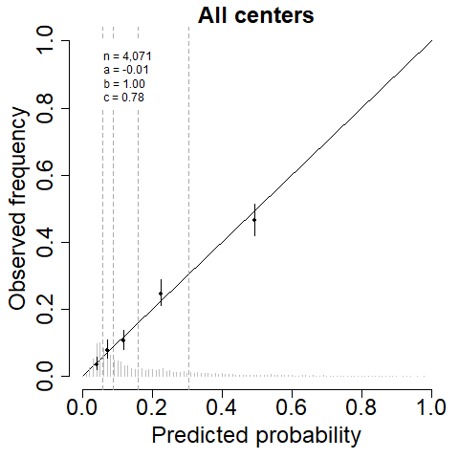

**Figure S3. Calibration curves of the final model predicting recurrence for each centre only for positive sentinel node patients obtained using leave-one-out internal-external validation.**

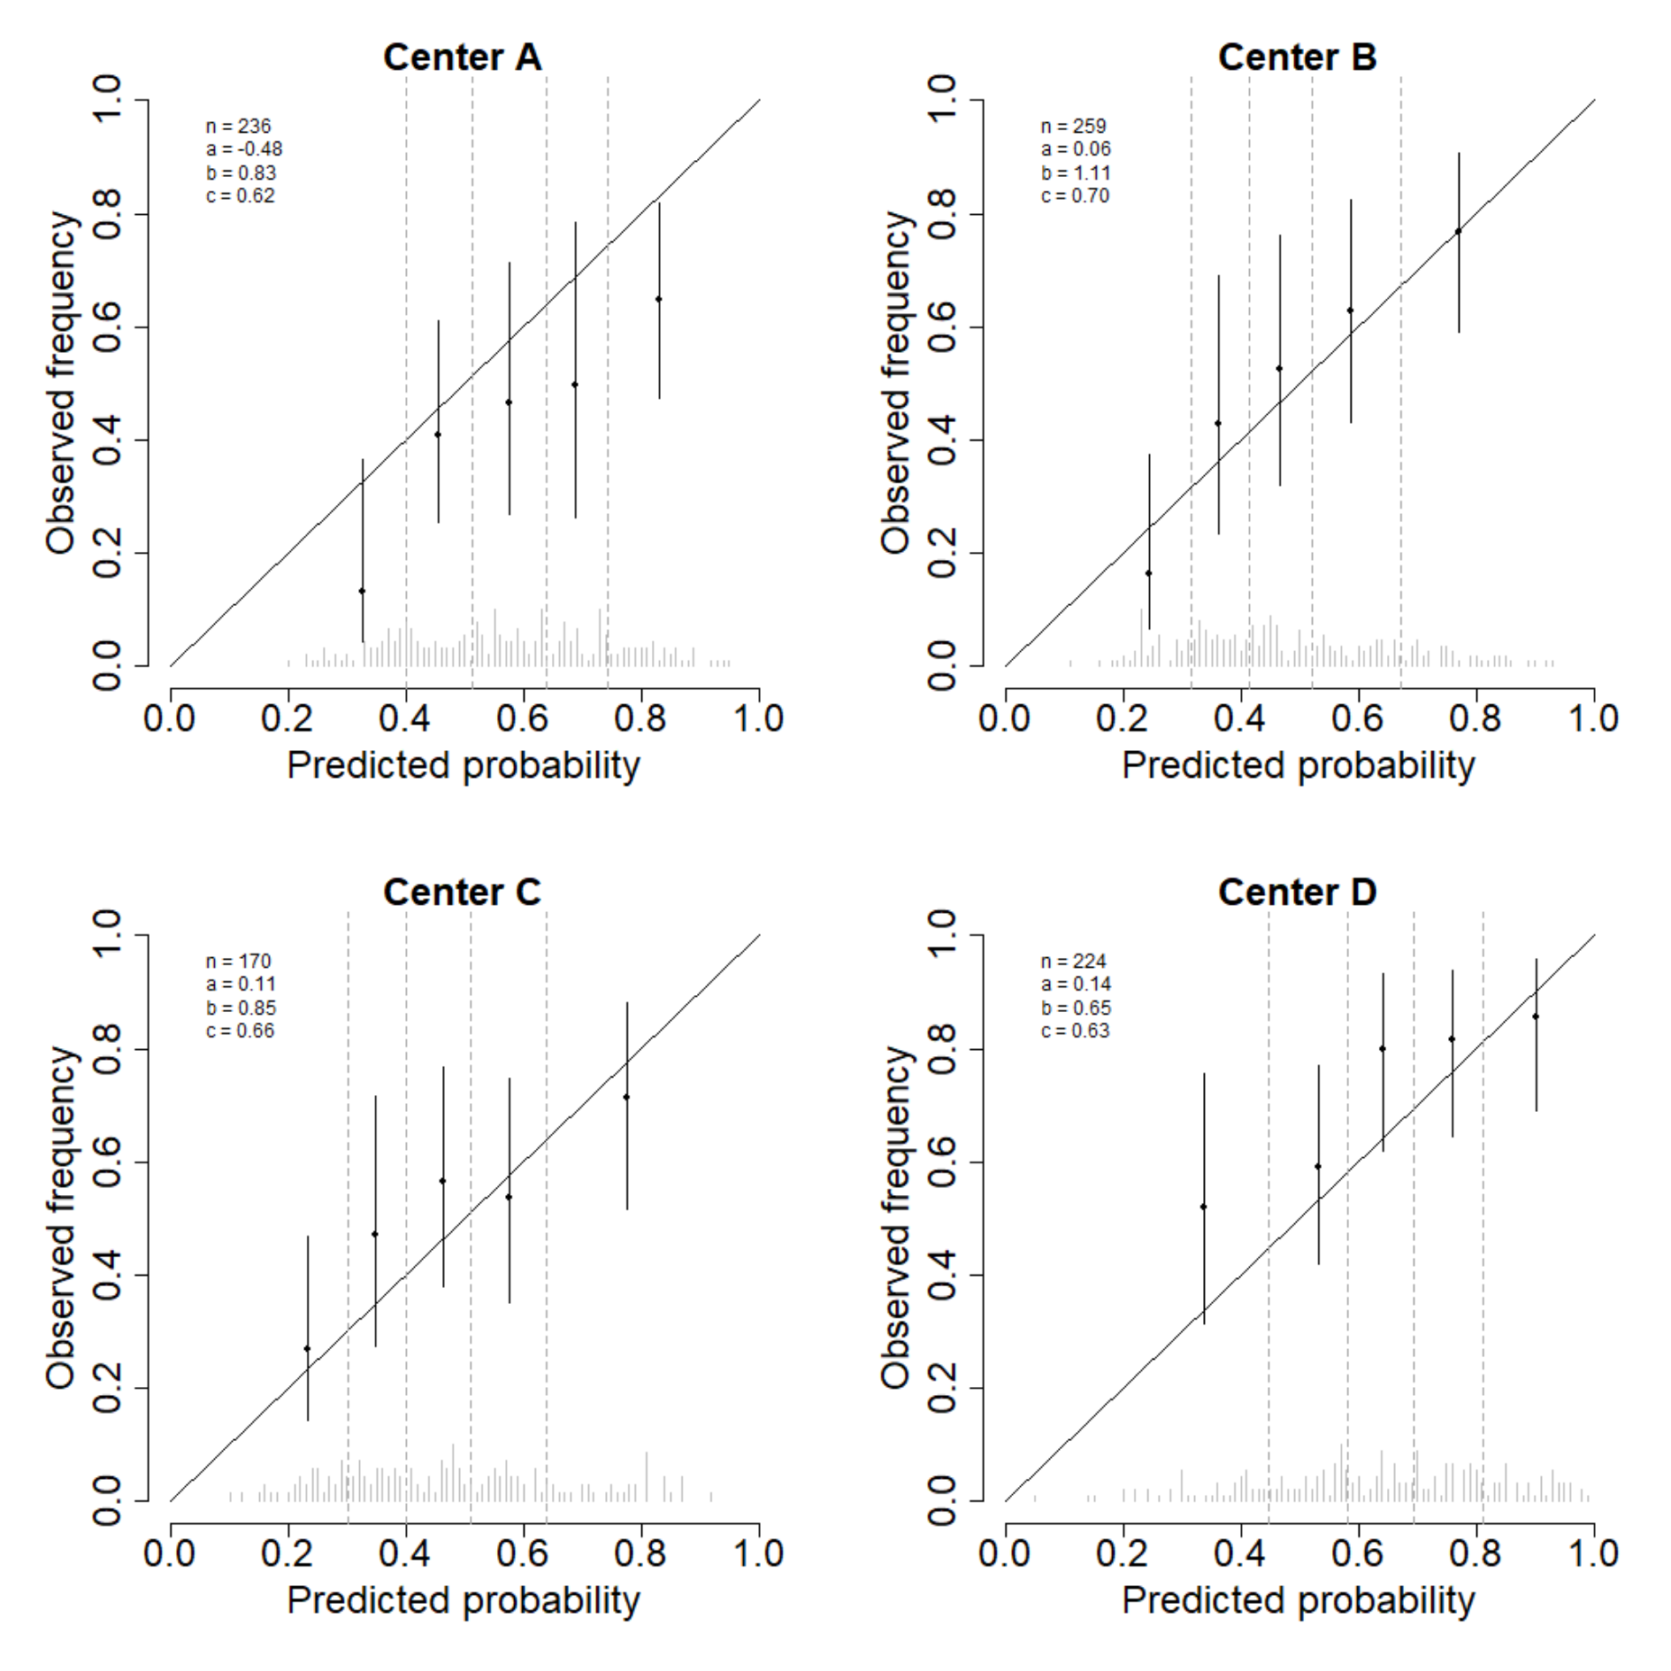

**Figure S4. Calibration curves of the final calibrated model predicting melanoma specific mortality for each centre only for positive sentinel node patients obtained using leave-one-out internal-external validation.**

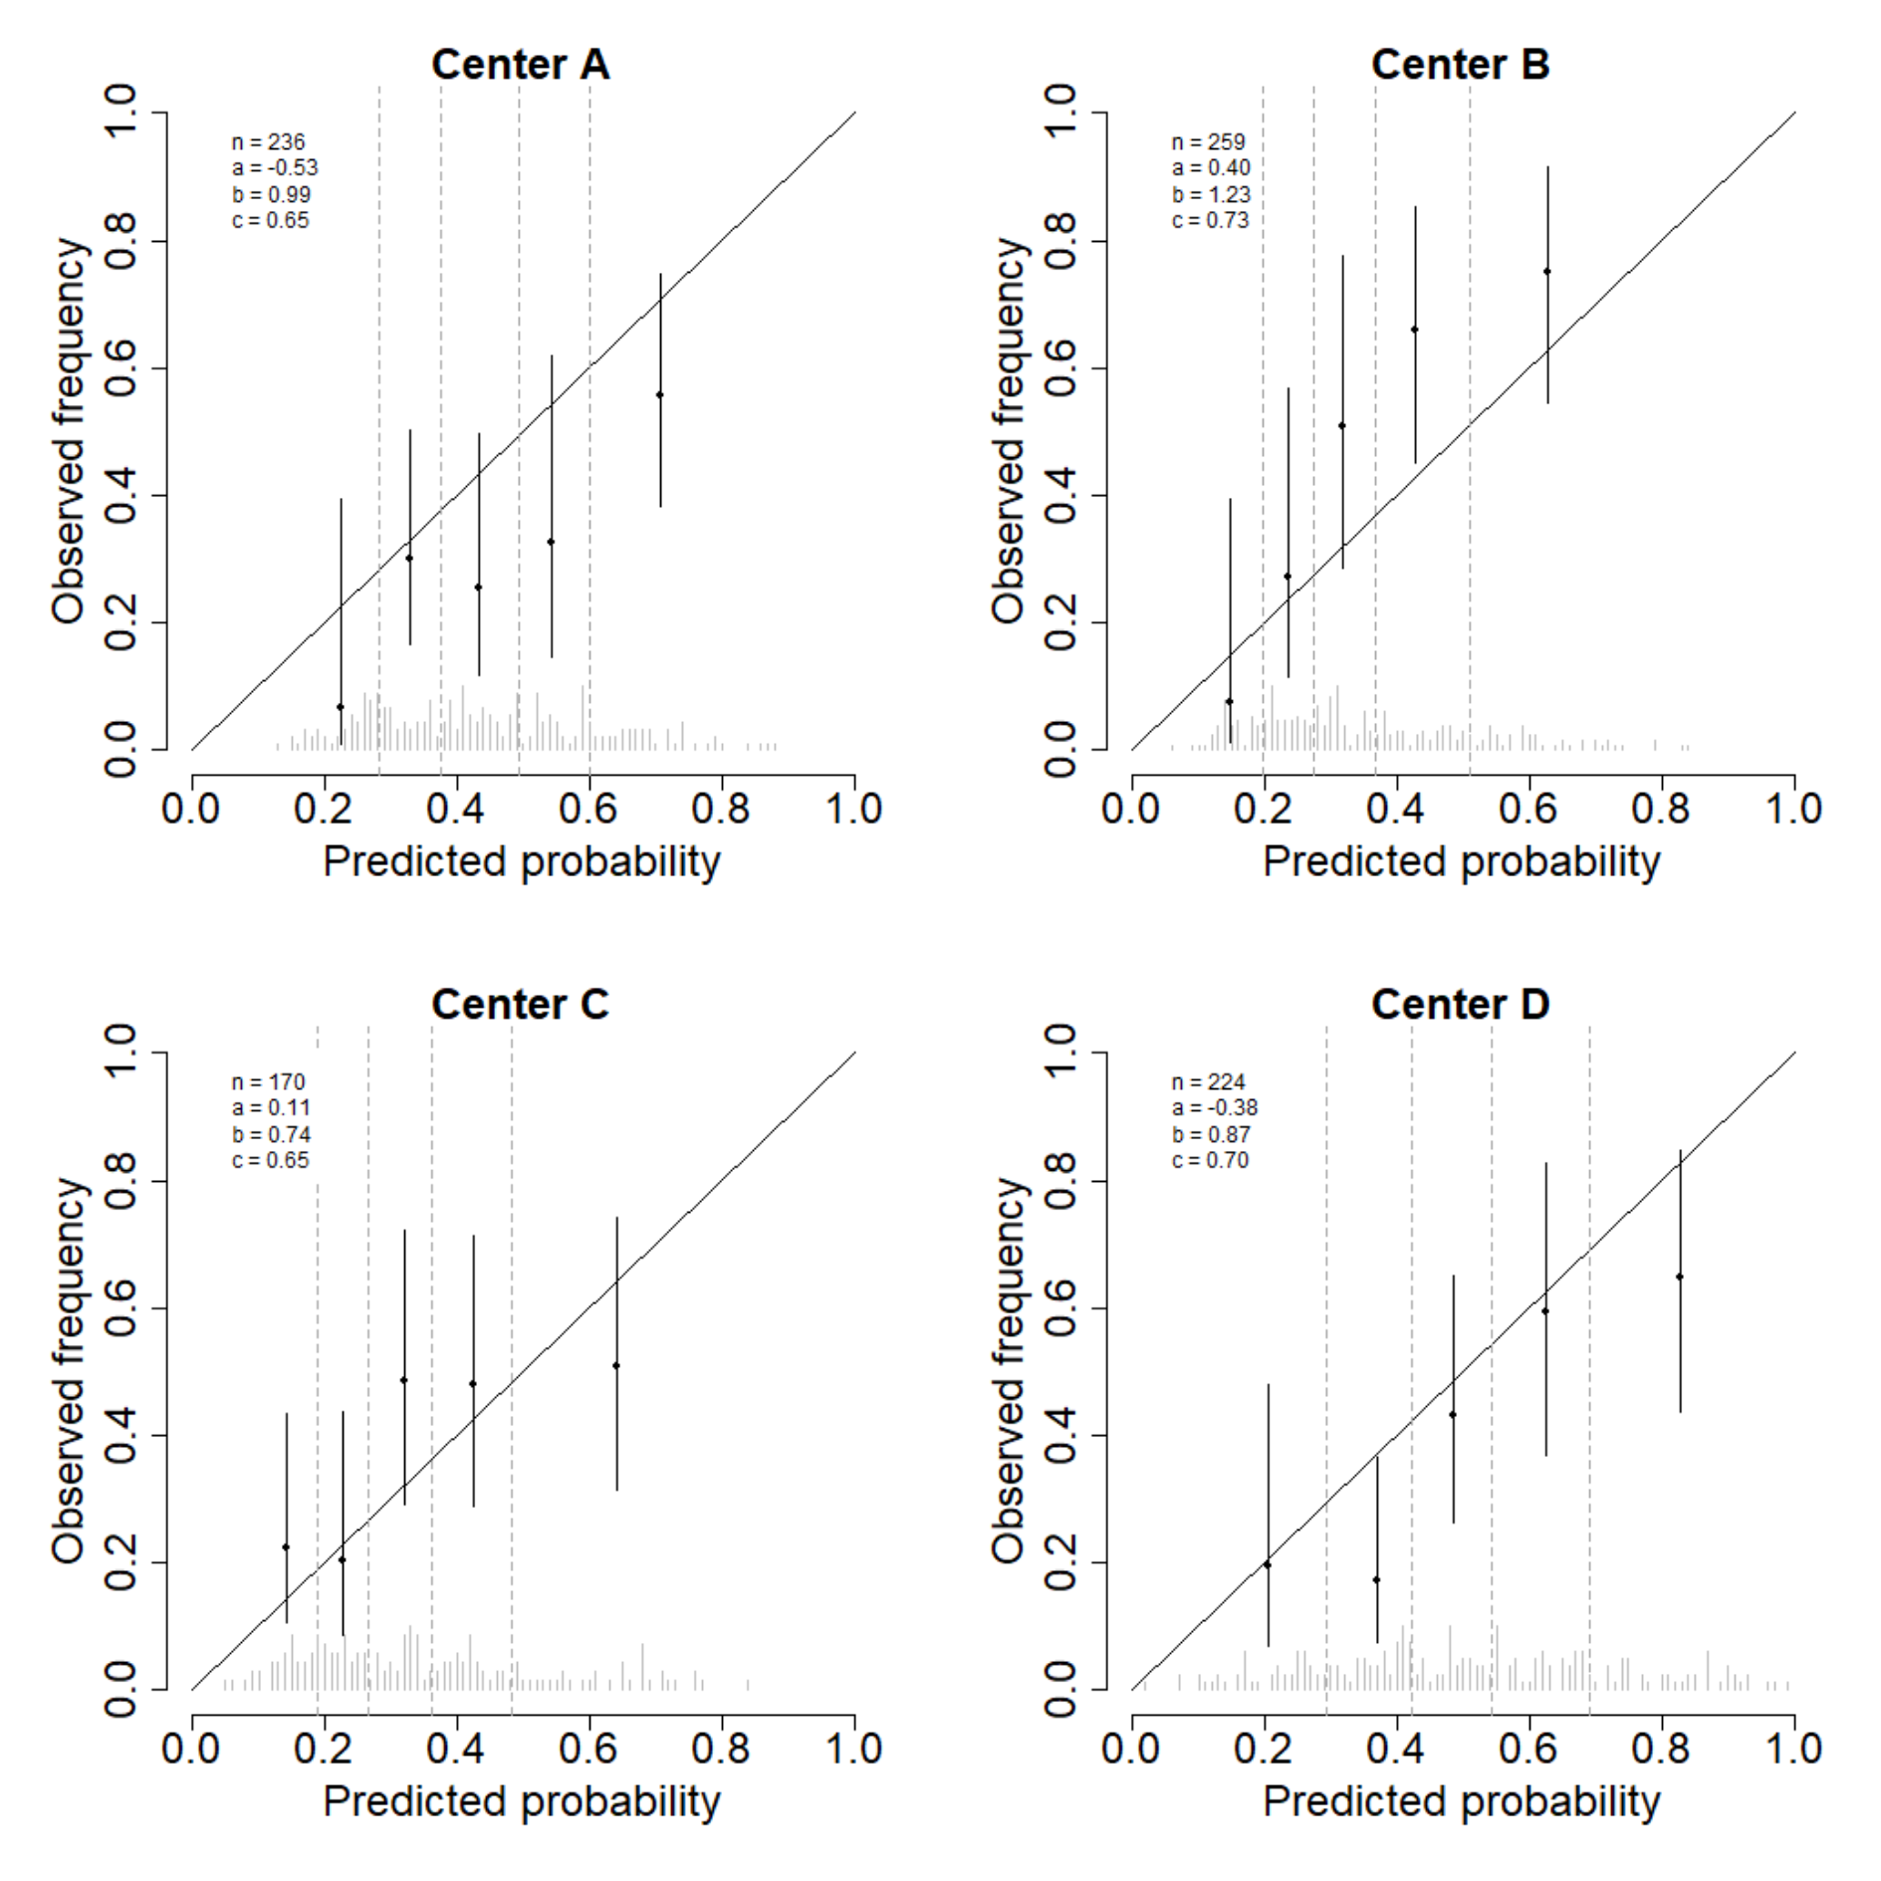

**Figure S5. Calibration curves of the final model predicting recurrence for each centre only for negative sentinel node patients obtained using leave-one-out internal-external validation.**

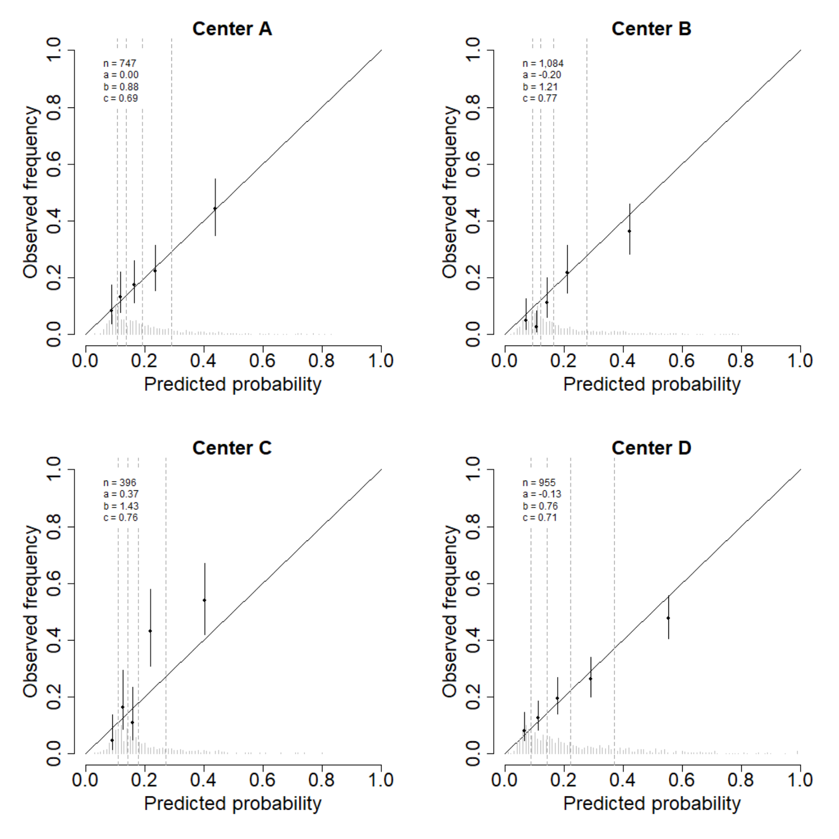

**Figure S6. Calibration curves of the final calibrated model predicting melanoma specific mortality for each centre only for negative sentinel node patients obtained using leave-one-out internal-external validation.**

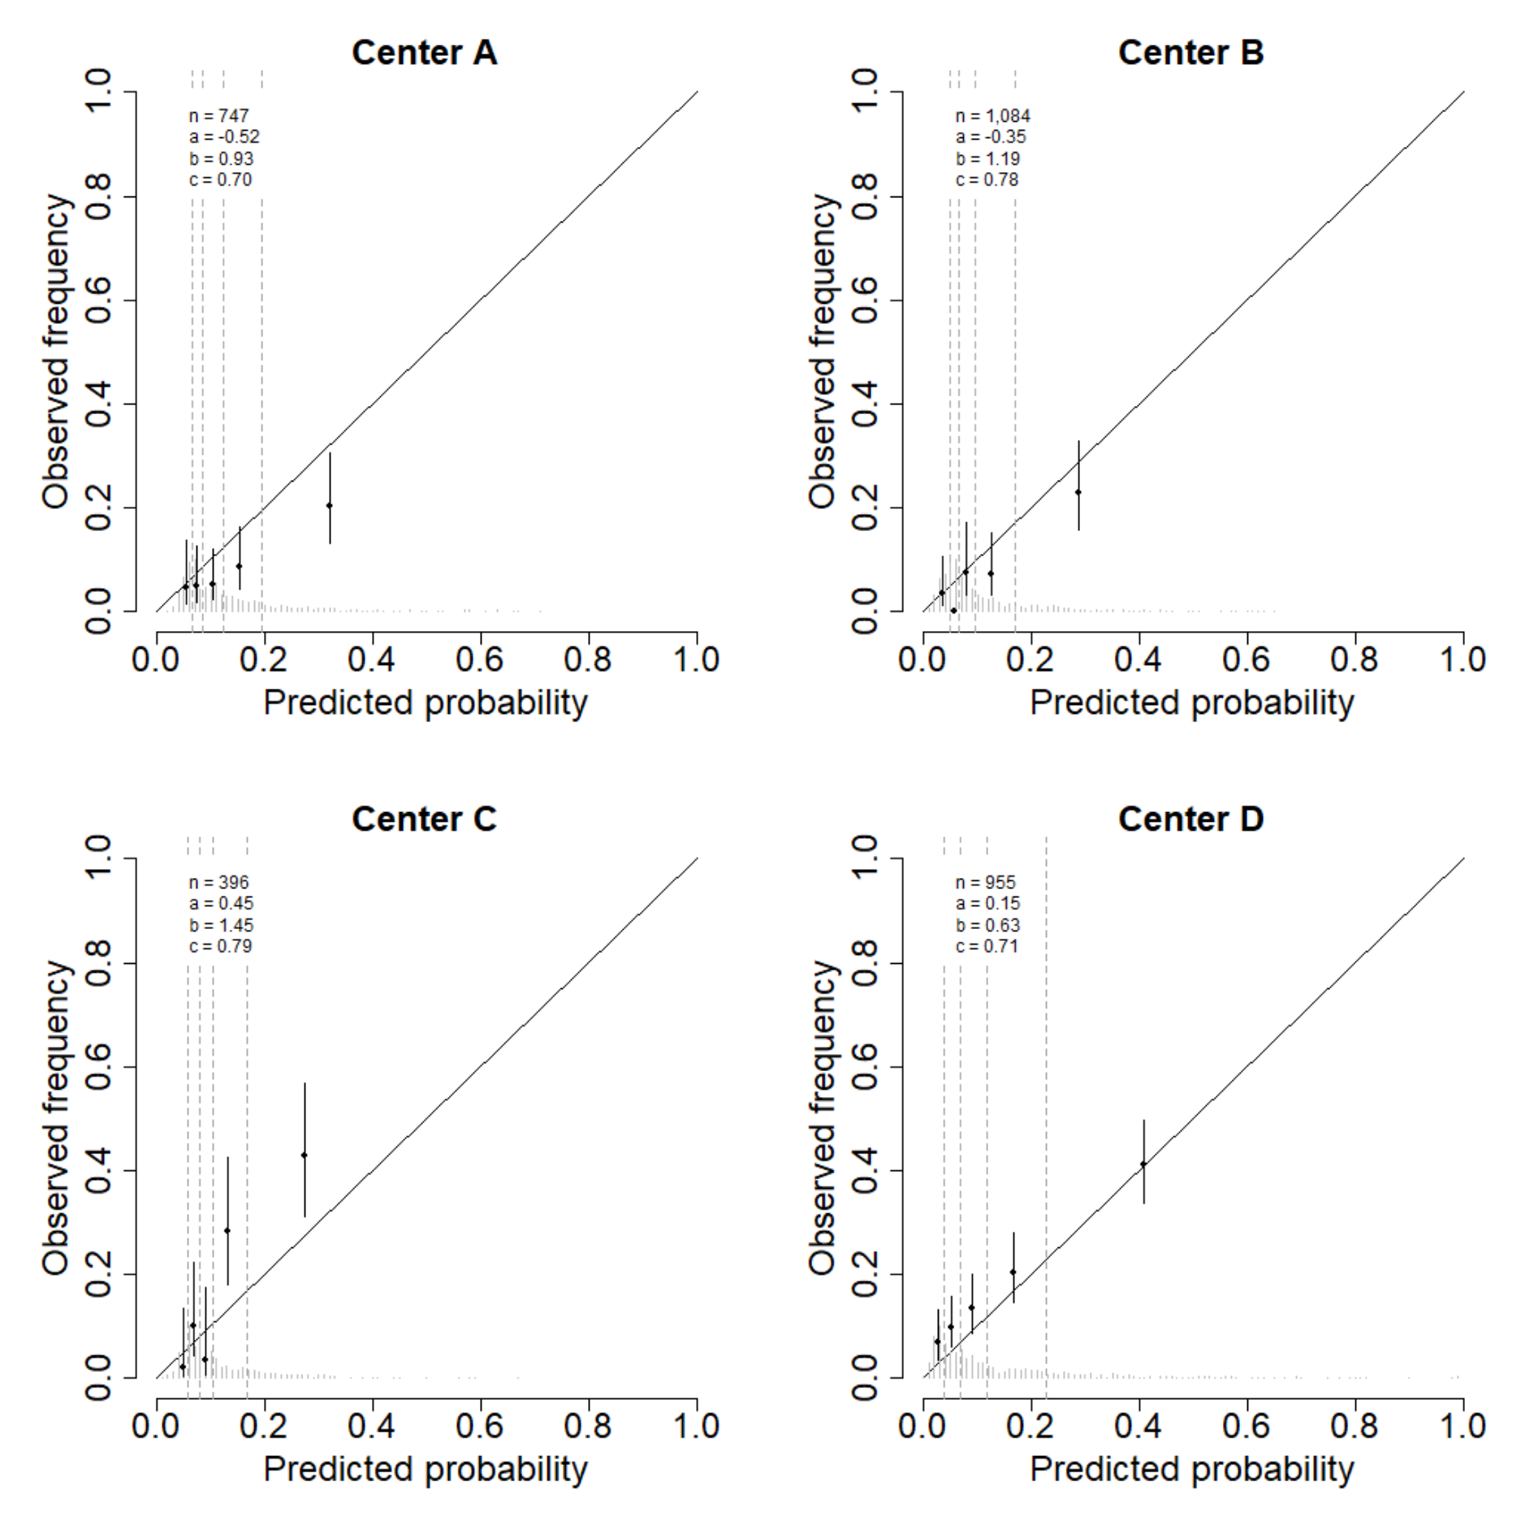

**Table S1. Refitted full model predicting 5-year melanoma specific mortality**. This Table displays the hazard ratios together with the 95 percent confidence intervals of the refitted full Cox proportional hazards model predicting 5-year melanoma specific mortality.

|  |  |  |  |  |  |  |
| --- | --- | --- | --- | --- | --- | --- |
|  | **Negative SN** | | **Positive SN** | | **Importance** | |
|  | **HR** | **CI** | **HR** | **CI** | **Main** | **Int.** |
| **Positive SN status** |  |  | 0.311 | [0.02; 3.93] | 33.6 | 25.3 |
| **Male** | 1.36 | [1.06; 1.76] | 1.13 | [0.60; 2.13] | 6.5 | 1.0 |
| **Age** | 0.81 | [0.55; 1.19] | 1.65 | [0.61; 4.47] | 5.7 | 5.4 |
| **Ulceration** | 2.08 | [1.60; 2.71] | 1.64 | [0.85; 3.17] | 39.3 | 1.4 |
| **Location** |  |  |  |  |  |  |
| Arm | (ref) |  | (ref) |  |  |  |
| Leg | 1.05 | [0.70; 1.56] | 0.96 | [0.30; 3.09] | 19.6 | 3.9 |
| Trunk | 1.72 | [1.19; 2.49] | 1.09 | [0.35; 3.37] |  |  |
| Head and neck | 1.67 | [0.98; 2.85] | 1.77 | [0.43; 7.30] |  |  |
| **Histology** |  |  |  |  |  |  |
| SSM | (ref) |  | (ref) |  |  |  |
| NM | 1.12 | [0.82; 1.51] | 1.08 | [0.51; 2.27] | 4.8 | 0.4 |
| ALM | 1.59 | [0.77; 3.30] | 1.71 | [0.32; 9.19] |  |  |
| Other | 1.01 | [0.57; 1.80] | 0.63 | [0.07; 5.71] |  |  |
| **Breslow** | 2.33 | [1.92; 2.82] | 1.60 | [0.99; 2.56] | 93.6 | 6.8 |
| **Multiple fields** | 1.05 | [0.69; 1.61] | 1.40 | [0.51; 3.81] | 2.5 | 0.9 |
| **Total number of SN** | 0.95 | [0.88; 1.03] | 0.95 | [0.77; 1.19] | 1.5 | 0.2 |
| **SN tumour burden** |  |  | 1.22 | [1.03; 1.43] | 5.5 |  |
| **Location metastasis in lymph node** |  |  |  |  |  |  |
| Subcap |  |  | (ref) |  |  |  |
| Combined |  |  | 1.15 | [0.74; 1.81] | 1.0 |  |
| Parenchymal |  |  | 1.24 | [0.67; 2.29] |  |  |
| Multifocal |  |  | 1.12 | [0.59; 2.12] |  |  |
| Extensive |  |  | 1.34 | [0.73; 2.47] |  |  |
| *C-index2* | 0.79 | [0.77; 0.81] |  |  |  |  |

1The hazard ratio of positive sentinel node patients includes the effects from the interaction terms. 2The C-index is corrected for optimism. Abbreviations: SN, sentinel node; HR, hazard ratio; CI, 95 percent confidence interval; Importance defined by the chi-square Wald-statistic; Main the Wald-statistic for the main effect of the coefficient; Int., the Wald-statistic for the interaction term with positive SN status; SSM, superficial spreading melanoma; NM, nodular melanoma; ALM, acral lentiginous melanoma.

**Table S2. Refitted final model predicting 5-year melanoma specific mortality**. This Table displays the hazard ratios together with the 95 percent confidence intervals of the refitted Cox proportional hazards model predicting 5-year recurrence selected by backward selection with p-values maximum of 0.01.

|  |  |  |  |  |  |  |
| --- | --- | --- | --- | --- | --- | --- |
|  | **Negative** | | **Positive** | | **Importance** | |
|  | **HR** | **CI** | **HR** | **CI** | **Main** | **Int.** |
| **Positive SN status** |  |  | 2.83 | [2.23; 3.59] |  | 79.9 |
| **Age** | 1.20 | [0.89; 1.62] | 1.20 | [0.89; 1.62] | 1.5 |  |
| **Ulceration** | 1.86 | [1.53; 2.26] | 1.86 | [1.53; 2.26] | 38.1 |  |
| **Location** |  |  |  |  |  |  |
| Arm | (ref) |  | (ref) |  |  |  |
| Leg | 1.01 | [0.73; 1.40] | 1.01 | [0.73; 1.40] | 17.8 |  |
| Trunk | 1.46 | [1.07; 2.00] | 1.46 | [1.07; 2.00] |  |  |
| Head and neck | 1.72 | [1.15; 2.58] | 1.72 | [1.15; 2.58] |  |  |
| **Breslow** | 2.41 | [2.06; 2.82] | 1.58 | [1.05; 2.38] | 136.0 | 11.0 |
| **SN tumour burden** |  |  | 1.26 | [1.13; 1.41] | 16.3 |  |
| *C-index1* | 0.78 | [0.76; 0.80] |  |  |  |  |

1The C-index is corrected for optimism. Abbreviations: SN, sentinel node; HR, hazard ratio; CI, 95 percent confidence interval; Importance defined by the chi-square Wald-statistic; Main the Wald-statistic for the main effect of the coefficient; Int., the Wald-statistic for the interaction term with positive SN status.



**Other results**

**Table S1. Average number of patients in each class of AJCC7 and AJCC8 of the five imputed data sets.**

|  |  |  |
| --- | --- | --- |
| Class | AJCC7 | AJCC8 |
| IA | 217 | 253 |
| IB | 1532 | 1496 |
| IIA | 692 | 692 |
| IIB | 495 | 495 |
| IIC | 250 | 250 |
| IIIA | 471 | 199 |
| IIIB | 407 | 208 |
| IIIC | 8 | 476 |
| IIID | 0 | 4 |

*Class IIID is not a class defined by the AJCC7.

**Table S2. Discriminative performance of the AJCC7 and AJCC8 for all patients, patients with positive sentinel node, or patients with negative sentinel node.**

|  |  |  |  |  |  |
| --- | --- | --- | --- | --- | --- |
|  | AJCC7 | |  | AJCC8 | |
|  | C-index1 | CI |  | C-index1 | CI |
| All patients | 0.73 | [0.71; 0.75] |  | 0.73 | [0.72; 0.75] |
| Positive SN status | 0.58 | [0.55; 0.60] |  | 0.62 | [0.59; 0.64] |
| Negative SN status | 0.71 | [0.68; 0.73] |  | 0.71 | [0.69; 0.73] |

1The C-index is corrected for optimism

**In text**

The date of recurrence was missing for 45 (1.1%) patients, whilst it was indicated that recurrence did occur within the follow-up time. The majority of these patients were from centre D (42 patients, 7.4%), two patients from centre B (0.1%), and one patient from centre A (0.1%). The time-to-recurrence for these 45 patients was imputed using single imputation.

Association between linear predictors of recurrence and MSM was even stronger / was of the same size (calibration slope: 1.10 [1.00; 1.20]).

|  |  |  |  |  |  |
| --- | --- | --- | --- | --- | --- |
|  | Recurrence | |  | MSM | |
|  | n | % |  | n | % |
| All patients | 862 | 21.2 |  | 504 | 12.4 |
| Positive SN status | 363 | 40.8 |  | 221 | 24.9 |
| Negative SN status | 499 | 15.7 |  | 283 | 8.9 |